## horizontal line

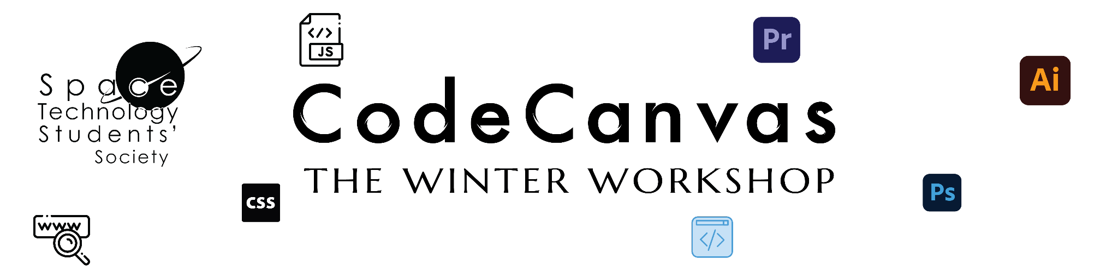

# 

# 

**Week 2**

**Illustrator in Design**

**12th December 2023**

# Overview

Illustrator is a crucial tool in today's design world. It's great for creating logos, illustrations, and various design elements, whether for print or online. With its easy-to-use features and versatile tools, Illustrator has become a go-to for graphic design, marketing, and web development professionals. It goes beyond the basics, playing a key role in branding and emerging as a must-have for effective visual communication in our digital age. So, let's start exploring and make design work for you!

# Goals

1. To learn all the basic tools and also some advanced concepts, such as

* **Adding Shapes.**
* **Adding Curved Texts.**
* **Using Pen Tool.**
* **Adding style and filter to your texts.**
* **Adding gradient backgrounds.**
* **Using the Pathfinder Tool.**
* **Using the Perspective Tool.**

1. To make a hands-on project that can be added to your ever-growing design portfolio.

# Getting Started

## Software Setup and Beginner Tips

* First, you will need to get Adobe Illustrator installed on your systems. The following link will provide you with the download link of the software: [Adobe Suite](https://drive.google.com/drive/folders/1pjPehttM-Oz_D0KSdj4ZOzJ8VZRpi7Nt)
* Adobe Suite for Mac users: [Mac](https://drive.google.com/drive/folders/1Zcb8POxSgz49sXiTc17sXT7AZf_DQP2K)
* Next will be setting up the software for your system and then applying some **changes to the layout** so that it will be helpful for you to access some of the properties and cool styles on the go. You can see the slides provided here; [Setting up Illustrator](https://docs.google.com/presentation/u/0/d/1fyH_Q3n2XfbEimfz0S7Pu476o0m260X6EfMb5v3qJ64/edit) afterwards for doing the same.
* Illustrator creates temporary files as you work but can take up space on your computer. They can quickly fill up your storage, so the best way to avoid that is to change your **scratch disks**.
* A **scratch disk** is just the storage drive you use to store the temporary files; once the program is closed, all the temporary files are removed automatically. You can see how to change a scratch disk in the previous slide. This not only keeps your system tidy but ensures smoother Illustrator functionality.
* Illustrator offers different workspaces tailored for specific tasks, such as Essentials, Typography, and more. Explore these workspaces to discover which one aligns best with your design workflow. Each workspace is designed to optimize tools for specific needs.

## Exporting your Image

* In the end, when you are done making your designs, you need to **export** them in **specific formats** that your employer will request.
* Most often in graphics, the format used is an image format. These formats are **.svg, .png**, **.jpeg** or some other image formats.
* In the following slides, you can learn how to export your designs: [Exporting in Illustrator](https://docs.google.com/presentation/u/0/d/1bOjQNZCtuCZCTN5DihUhVNJofZ0eJNzzQ7efYAej1fc/edit)
* Learning to export effectively will help you a lot when your files don't go missing and are in the proper format.

# Lessons

## Making shapes and adding Colors to it.

Creating shapes and adding colours in Adobe Illustrator is fundamental to graphic design. This process involves using the Shape and Pen tools to craft precise and customizable shapes. Additionally, the application's colour features allow designers to select, mix, and apply a spectrum of colours to these shapes, contributing to the design's visual appeal and overall aesthetics. Mastering these basics is essential for creating visually engaging and professional graphics in Illustrator.

**In this lesson, we will create a SUN with an appealing background**.

* First, we will take the rectangle tool, cover the whole artboard, and fill it (the colour of your choice) to create a background. After that, lock that rectangle in your Layers panel to fix it.
* Then, we will select the ellipse tool, hold Shift, and drag to make a perfect circle. Turn off the **Stroke** to remove the outline of the Circle. Select the colour from the properties and adjust the RGB according to the object.
* Now, select the **Polygon tool** and click once on the artboard; a dropdown menu will appear, and then type the number of sides = 3. Then, hold Shift and drag to create a triangle.
* Now select both the objects with the selection tool and click on vertical-align in the properties.
* Now, select the **Rotate tool** and click on the triangle, then hold **Alt and drag** it into the circle's centre. A dropdown menu will appear; type (360 / 8) in the angle box. Type with correct spacing as shown and click Copy to get another triangle.
* Then, Click **Ctrl + D** to duplicate the triangle around the circle.
* You can watch this video for more clarity on using the Rotate tool: [Rotate Tool](https://www.youtube.com/watch?v=_HUutj5QjXc&list=PLW-zSkCnZ-gCq0DjkzY-YapCBEk0lA6lR&index=6)

See the image for reference : 

## 

## Using the Pathfinder Tool and Adding Gradient to shapes

## **Pathfinder Tool:**

The Pathfinder tool in Illustrator is a powerful feature for combining, dividing, and manipulating shapes. It offers various operations like unite, intersect, exclude, and more, allowing users to create complex shapes by merging or subtracting existing ones. This tool is instrumental in creating custom shapes, icons, and illustrations, enhancing graphic design's versatility and creative possibilities.

Here, we will use this tool to make clouds and add a gradient.

* First, we will enable the Grid ( Go to “**View**” in the top menu and select “**Show grid**”)
* Now, we will draw a circle in any of the grids, then another circle beside it (a little bit bigger), and a bigger circle (double its size). Copy the first circle opposite to it and place it beside the bigger circle.
* Draw a rectangle of the length (diameter of all the circles). Shift and drag to make a perfect rectangle. Align it at the bottom of all the circles.
* Select the Pathfinder tool from the “Window” in the top menu. A dropdown menu will appear.
* In the Pathfinder panel (Unite, Minus Front, Intersect, Exclude, etc.), select “Unite” (in shapes of mode) to combine all the objects.
* You can watch this video for more clarity on using the Pathfinder tool: [Pathfinder Tool](https://www.youtube.com/watch?v=HRDbin0AQz4&list=PLW-zSkCnZ-gCq0DjkzY-YapCBEk0lA6lR&index=9)
* Now, you have successfully created a cloud. Now copy it by selecting it and pasting it as shown in the reference image below:



**Adding Gradient to Shapes:**

Gradients are another part of the design, used to show transitions between colours or can be used by experts to make some amazing masks and edits. Patterns are just repetitions of the same shape or object that create a visually appealing element in the Scene.

* Choose the shape you want to apply a gradient to using the Selection Tool.
* Select "**Gradient**" to open the Gradient panel.
* In the Gradient panel, choose the type of gradient you want (Linear, Radial, etc.).
* Adjust the colour stops on the gradient slider to define the colour transition.
* If using a linear gradient, adjust the angle to control the direction of the gradient.
* Click on individual colour stops to change their colour or opacity for a customized look.
* Click and drag across the shape to apply the gradient, or use the Gradient Tool for more precise adjustments.
* You can watch this video for more clarity on using the Gradient tool: [Gradient Tool](https://www.youtube.com/watch?v=SrNq5ipQ5YM&list=PLW-zSkCnZ-gCq0DjkzY-YapCBEk0lA6lR&index=7)

See the image for reference : 

## Using the Perspective Grid Tool

The Perspective Grid Tool in Illustrator enables the creation of three-dimensional effects by establishing a visual grid with vanishing points. It facilitates the design of objects in a realistic perspective, enhancing the depth and spatial aspects of illustrations and infographics.

* First, to enable the Perspective tool,

1. go to the "View" menu.
2. Select "**Perspective Grid**" and choose "Show Grid."

You can also use the shortcut **Ctrl+Shift+i** (Windows) and **Cmd+Shift+i** (Mac) to enable it.

* To adjust the Grid, click and drag on the grid handles to place them in perspective.
* First, make the required shapes individually to assemble the 3-D object. Then, drag and drop the objects onto the grid to place them in perspective.
* Use the **Perspective selection tool** to switch between different planes of the grid.
* To exit the grid view again, use the shortcut key.
* You can watch this video for more clarity on using the perspective grid tool: [Perspective Grid Tool](https://www.youtube.com/watch?v=rDAaoAyCKxM&list=PLW-zSkCnZ-gCq0DjkzY-YapCBEk0lA6lR&index=22)

**Reference Image**

In this, we have created a dam from the final image using the above method.

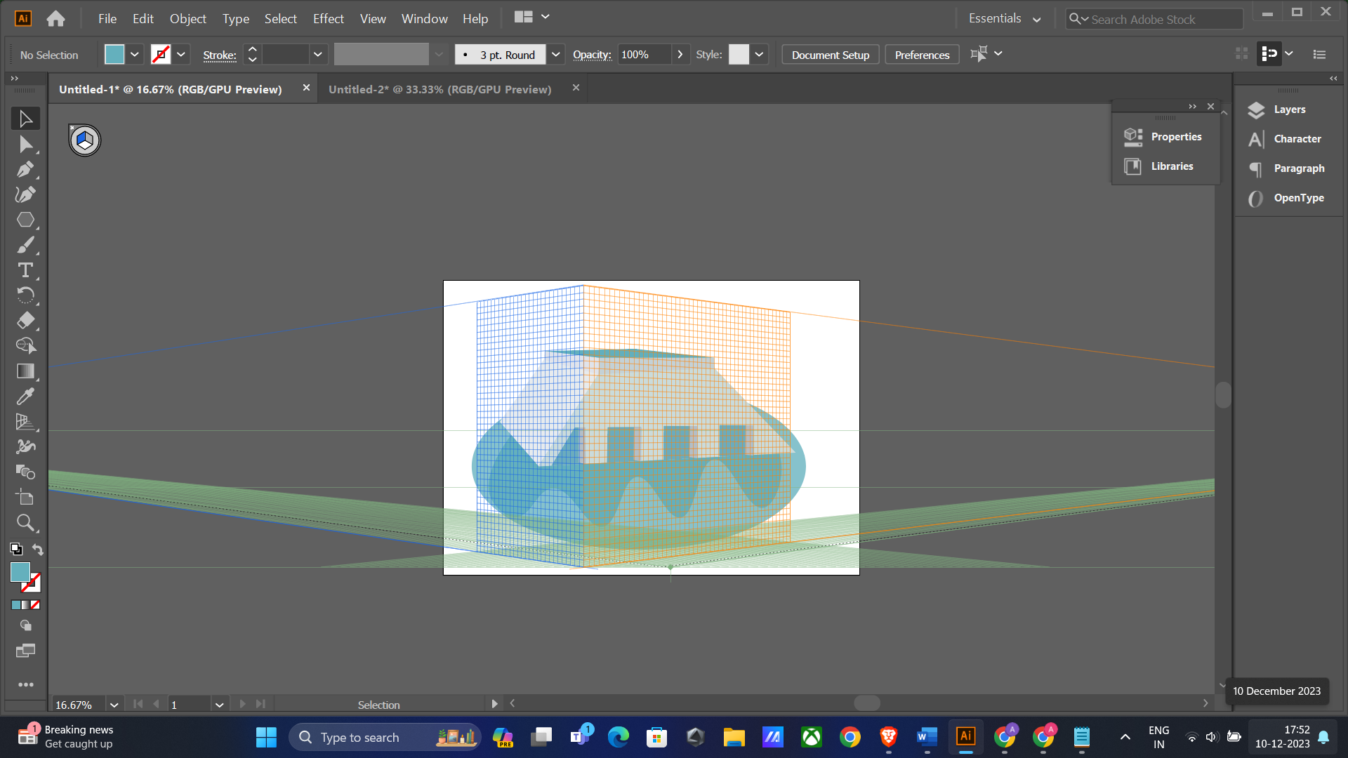



## The Final Showdown

For the final piece of the puzzle, we will combine all these elements to make an infographic by using the learned techniques and adding text in different styles. We have made an ecology infographic using the parts we created with the help of the above lessons.

**Your final task is to choose a topic of your choice and form elements using the abovementioned lessons. You can form different elements of your choice according to your topic and add text while experimenting with different fonts and styles.**

See the image for reference:

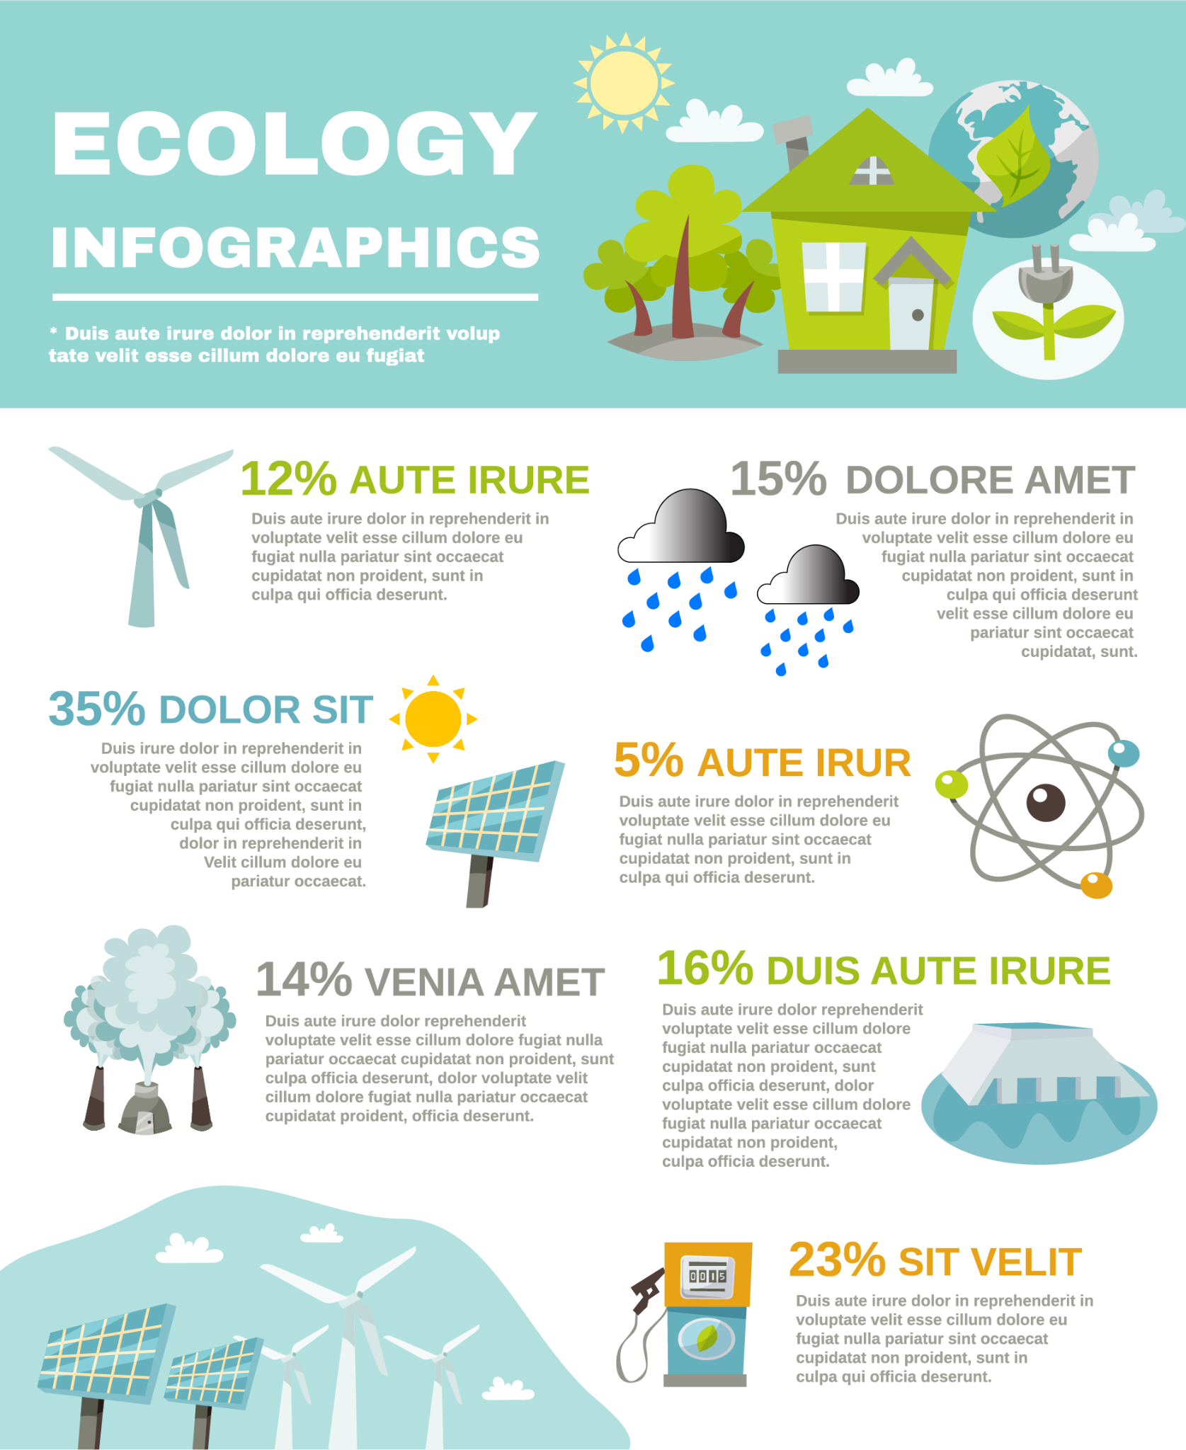

# 

# 

# 

# 

# 

# Resources

These are the resources that you will need to learn some of the basics of the software and we have also added a few of our special links where we go for inspiration and also to learn.

Tutorials to learn the basics of Illustrator: [Illustrator Basics](https://www.youtube.com/playlist?list=PLW-zSkCnZ-gCq0DjkzY-YapCBEk0lA6lR)

Videos to watch in this playlist are 1-15, 19, 21-22 and 28.

Getting stuck with choosing colours or a range of colours, you can try this amazing website that professionals use to get colour palettes: [Coolors - The super fast colour palettes generator!](https://coolors.co/)

**Submission**

You will have to export the **.png** of each of the Lessons that you complete and also separate **.ai** files in a Google Drive folder with proper access given for the grading of your responses.

A Google form will be shared with you through email where you will be submitting your creations.

**Hope you enjoyed your creative journey through Illustrator. Be ready for the upcoming learning ahead.**